Bible Readings and Prayers
20th September – 2nd October 2021

Your word is a lamp to guide me
and a light for my path.
— Psalm 119:105

In these few pages are some suggested Bible readings and prayers.

- You might enjoy spending some time each day reflecting on a short passage from Scripture. If you are already using another Bible reading guide, or selection of readings, please continue to use those and don’t feel you should switch to these.

- Included are also a few prayers which might provide a starting point for your own prayers. There may be just one prayer here that particularly appeals to you – in which case, stay with that one.
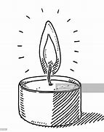
It is lovely to hear that a number of parishioners are putting aside some time at 7pm each night to light a candle and join in prayer for others. (If that particular time doesn’t suit you, by all means choose another time.)

Suggestions as you approach the Bible reading/s:

In this iteration of the parish Bible reading guide we have included a daily psalm as well as the gospel reading for the day. You might choose to read one or both of the readings. Read it slowly twice. Notice what strikes you most - it might be just one word or a phrase. Ponder on that and speak to God about it. Use the accompanying question for the day if it seems helpful.

- What does the text (Bible passage) say? What is going on?
- What does the text say to me? What relevance does it have to my daily life?
- What do I want to say to God about this text?
- What now?

The Bible readings come from the Revised Common Lectionary. It may bring you encouragement to know that all over the world today other people will be praying with these readings, just as you are.
Bible readings

Monday 20th Sept: Mark 12:28-34 + Psalm 44
“Love the Lord with all your heart, with all your soul with all your mind and with all your strength.” How am I doing in responding to this commandment? I ask for God’s help today.

Tuesday 21st Sept: Matt 9:9-13 and Psalm 19:1-6
Which phrase stands out for me most today? I respond to Jesus’ words.

Wednesday 22nd Sept: Mark 13:1-13 and Psalm 59
Jesus warns a handful of his disciples about troubles and persecutions they will face. He promises that the Holy Spirit will strengthen and equip them when these events occur. What troubles am I facing today? What troubles in our world concern me? I bring these things to God in prayer.

“The Lord is close to the brokenhearted and saves those who are crushed in spirit.”
— Psalm 34:18

Thursday 23rd Sept: Mark 13:14-23 and Psalm 63
I reflect on the readings. Perhaps I might choose to pray for refugees and migrants.

Good Shepherd, no refugee is a stranger to you,
and no one is ever far from your loving care.
We pray for you to watch over refugee children and families
as they travel to refugee camps or relocate within their country.
Shelter their souls and their bodies.
Heal the hearts of refugees who have endured unimaginable tragedy and trauma.
https://www.worldvision.org/refugees-news-stories/pray-refugees-disaster-survivors

Friday 24th Sept: Mark 13:24-31 and Psalm 51
Psalm 51 is a heartfelt prayer of repentance. I may like to linger with this today.

“Something beautiful, something good
All my confusion, he understood
All had to offer him
Was brokenness and strife
But he made something beautiful of my life.”
[Song by William Gaither]

Saturday 25th Sept: Mark 13:32-end and Psalm 68
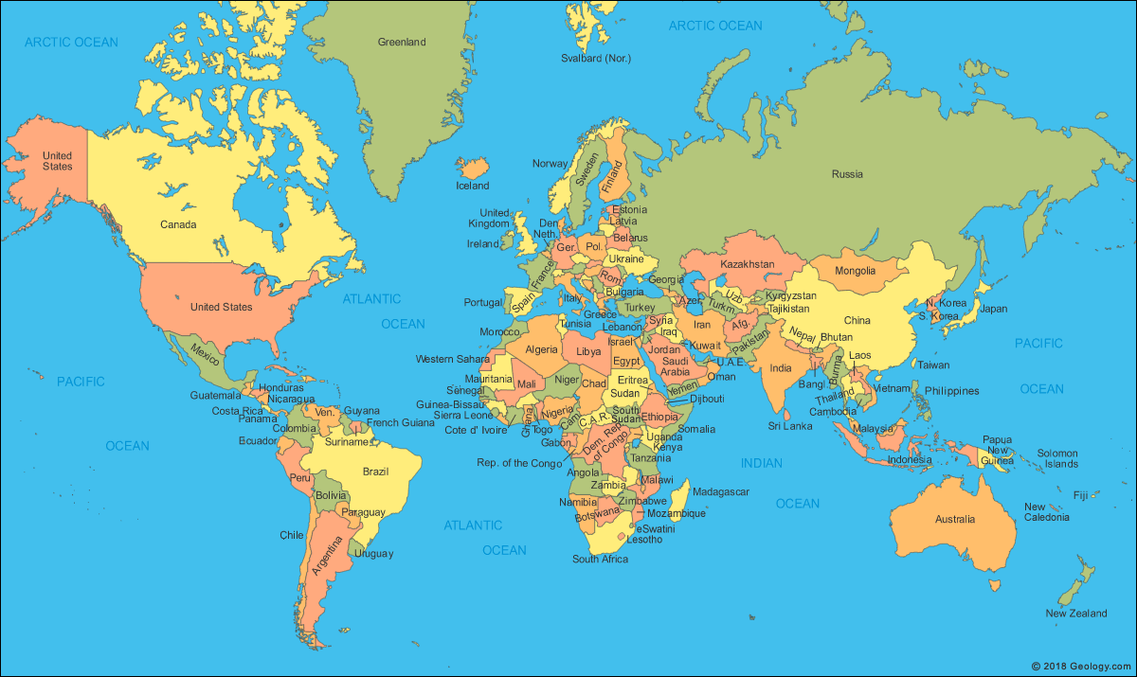

God of compassion,
you hear the cries of all who are in trouble or distress;
strengthen them in their hour of need,
grant them perseverance and courage to face the future.
We ask these things through Christ, our Lord.
Amen.
https://www.churchofengland.org/prayer-and-worship/topical-prayers/prayers-world

Monday 27th Sept: Mark 14:1-11 and Psalm 71
I imagine myself in the scene, using my senses. Where am I? What do I see around me? What do I hear, smell, taste, feel? What do I notice about Jesus? I stay with the experience and see what emerges.

Tuesday 28th Sept: Mark 14:12-25 and Psalm 73

Wednesday 29th Sept: John 1:45-51 and Psalm 103:15-22
“Come and see.” I ask for insight.

Thursday 30th Sept: Mark 14:43-52 and Psalm 78:1-40
What words stand out for me from today’s reading? Why?

Friday 1st Oct: Mark 14:53-65 and Psalm 55
I take time to let words from the gospel or the psalm move from my head to my heart.

A beautiful evening prayer by St Augustine (5th century African bishop):

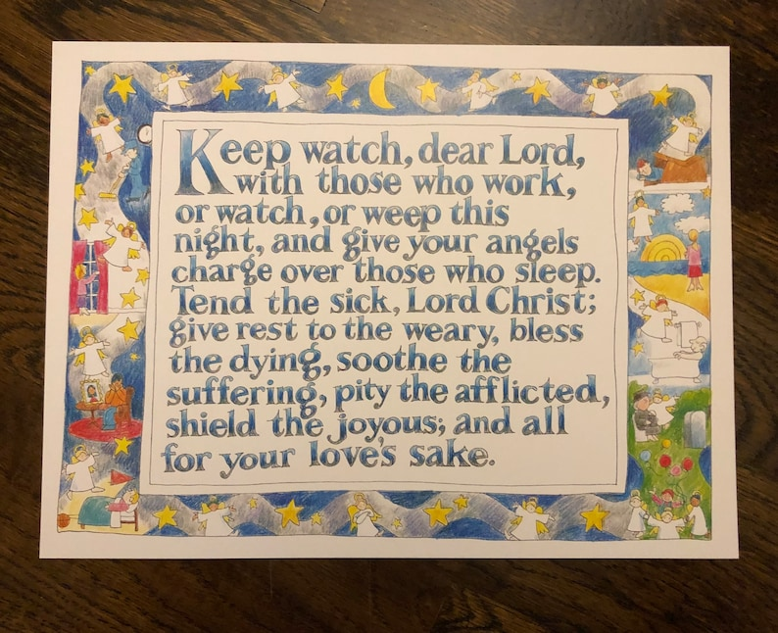

Saturday 2nd Oct: Mark 14:66-end and Psalm 76
I place myself in the scene. Who am I? Peter? The servant girl? Another bystander, keeping warm by the fire? What do I notice? What do I want to pray?

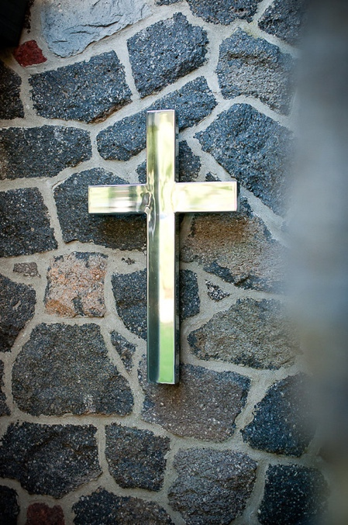
Lord,
it is night.
The night is for stillness.
Let us be still in the presence of God.

It is night after a long day.
What has been done has been done;
what has not been done has not been done;
let it be.

The night is dark.
Let our fears of the darkness of the world and of our own lives
rest in you.

The night is quiet.
Let the quietness of your peace enfold us,
all dear to us,
and all who have no peace.

The night heralds the dawn.
Let us look expectantly to a new day,
new joys,
new possibilities.
In your name we pray.
Amen.
A New Zealand Prayer Book: He Karakia Mihinare o Aotearoa

Perhaps you might like to break the following prayer from World Vision into parts, and pray just one or two sections of it over a number of days.

A Prayer of Intercession from World Vision’s “Week of Prayer”
for the coronavirus health crisis – https://www.wvi.org/weekofprayer.

Remembering your love that encompasses all and your call to solidarity, we come before you O God with our prayer:

O God, you like a mother, gather all peoples under your wings, no one is excluded, awaken in us that love which gives itself in care and commitment for the safety and protection of all. Turn, O God,
and deliver us!

O God, our creator, as hands are outstretched and arms are waiting for the vaccine, push us to find ways of equitable distribution that all available resources be allocated without discrimination and without unequal treatment. Turn, O God,
and deliver us!

O God, our guardian, every human being carries your image. You desire that all may have life and have it abundantly. Break down barriers of wealth and illusions of superiority that all may enjoy the highest attainable standard of physical and mental health as a basic human right. Turn, O God,
and deliver us!

O God, our refuge, sustain all medical workers, nurses, doctors, attendants, all hospital and clinic workers. Strengthen them in their expertise so that the number of deaths be minimized, lives preserved, protect them as they take great risk themselves. Turn, O God,
and deliver us!

O God, our hope, inspire scientists and lab workers in their continual search to improve the vaccine. Motivate pharmaceutical companies to seek rapid and just distribution without thinking first about profit. Turn, O God,
and deliver us!

O God, our ark, gather and protect the most vulnerable, those at the greatest risk of becoming ill, shield them and all of us from the raging waters of the pandemic. Bring a swift end to the virus and the suffering it causes. Turn, O God,
and deliver us!

O God, our truth, embolden religious leaders to confront unsubstantiated rumours and conspiracy theories that undermine public trust in science and in health authorities. Encourage them to speak up for the marginalized so that public policy decisions benefit all equally. Turn, O God,
and deliver us!

O God, our ruler, sway the governments of this world to speak truth, to provide correct and honest information and equitable policies of protection and care that the pandemic may be controlled and ended. Turn, O God,
and deliver us!

O God, our sustainer, support and preserve all workers and businesses that long-term hardship to the economy be avoided and that a peaceful and prosperous environment be created in which all are satisfied. Turn, O God,
and deliver us!

O God, hold in your tender embrace all who will die this day. Into your hands, O God,
We entrust all our prayers. Amen.

Gathered into one family by the Holy Spirit, let us pray as Jesus taught us:
Our Father, in heaven…

Benediction

May the goodness and favour of the Lord our God,
Eternal Majesty, Incarnate Word, Abiding Spirit
Embrace all creation
May the unconditional love of the Triune God
Envelop all in justice and peace.
O prosper the work of our hands that your shalom reigns. Amen.

