Minister:
Rev Silvia Purdie BA BTheol

Church Office:
2 Macmillan Avenue
Cashmere, Christchurch, 8022
Telephone 332 7129
Website: www.cashmerechurch.org.nz

Mission Statement
Cashmere Presbyterian Church will make the life and teachings of Jesus Christ known and will share in God’s loving purposes of truth, justice, peace and wholeness for all people and the world.
Sunday 2nd February 2020
Epiphany 4 ~ Sunday before Waitangi Day

Service led by David Troughton

A very warm welcome to you all, whether this is your first time or thousandth time in church. You are welcome whatever your age, gender, marital status, disability, poverty or wealth, race or sexuality. You are welcome whether you have a deep and mature faith in Christ; are uncertain and still seeking; or have no faith. If you are new to church, please do not hesitate to ask one of those on duty if you have any questions.

You are invited to stay for Morning Tea, which will be served in the Lounge after the service.

Order of Worship
(Congregational responses are in bold italics)
Please stand for the procession at the beginning of the service,
and at the conclusion of the service.

Candle-lighting (Ann Jennings)

Welcome and Call to Worship.
Let us worship God.
God treats everyone on the same basis.
Whoever worships Him and does what is right is acceptable to him,
no matter what race he belongs to. (Acts 10:34b,35)
God has brought us into union with Christ Jesus,..
By Him we are put right with God,
We become God’s holy people and are set free. (1Cor 1:30.)

Hymn 49: O God of Bethel.
Prayer of Thanksgiving (Jay Lee)

Prayer of Confession
Merciful God,
We have sinned
in what we have thought and said,
in the wrong we have done.
We have sinned in ignorance:
we have sinned in weakness:
we have sinned through our own deliberate fault.
We are truly sorry.
We repent and turn to you.
Forgive us, for our Saviour Christ’s sake,
and renew our lives the glory of your name. Amen
Silence

Words of Assurance.
Hear these words of assurance:
If we confess our sins to God
He will keep His promise and do what is right:
He will forgive us our sins
And purify us from all our wrongdoing. (1 John 1:9)
Thank you, Loving God, for your word to us. Amen.

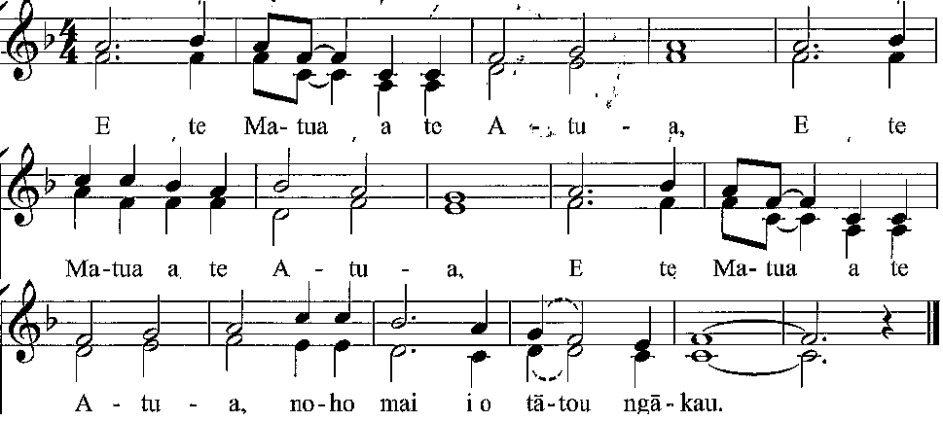
Prayer Song (remaining seated) HIOS 24
- E te Matua a te Atua (x3),
noho mai i o tatou ngākau.
- E te Tama a te Atua (x3),
arahina tatou katoa.
- E te Wairua Tapu, Atua (x3),
whakaū te Hatū katoa.
- E te Matua, Tama, Wairua Tapu (x3),
haere mai, haere mai.

God the Father, abide in our hearts.
God the Son, guide us all.
God the Holy Spirit, fill our lives.
Father, Son, Holy Spirit, come, come.

Children’s Special time

Notices, Passing of the Peace

Hymn: Let us build a house where love can dwell (CH4: 198)

- Let us build a house where love can dwell
and all can safely live,
A place where saints and children tell
how hearts learn to forgive.
Built of hope and dreams and visions,
rock of faith and vault of grace;
Here the love of Christ shall end divisions:
All are welcome, all are welcome,
all are welcome in this place.
- Let us build a house where prophets speak
and words are strong and true,
where all God’s children dare to seek
to dream God’s reign anew.
Here the cross shall stand as witness
and as symbol of God’s grace;
Here as one we claim the faith of Jesus:
All are welcome…
- Let us build a house where love is found
in water, wine and wheat:
a banquet hall on holy ground,
where peace and justice meet.
Here the love of God, through Jesus,
is revealed in time and space;
As we share in Christ the feast that frees us:
All are welcome…
- Let us build a house where hands will reach
beyond the wood and stone
to heal and strengthen, serve and teach,
and live the Word they’ve known.
Here the outcast and the stranger
bear the image of God’s face;
Let us bring an end to fear and danger:
All are welcome…
- Let us build a house where all are named
their songs and visions heard
and loved and treasured, taught and claimed
as words within the Word.
Built of tears and cries and laughter,
prayers of faith and songs of grace,
Let this house proclaim from floor to rafter:
All are welcome, all are welcome,
all are welcome in this place.

Bible Readings (Reader: Janice Lee)
Micah 6:1-8 (p.903 OT)
Matthew 3:1-12 (p.5 NT)

Sermon: Remember, Review, Respond: Towards Waitangi Day.
Preacher: David Troughton.

Offertory

Prayer of Dedication

The Lord’s Prayer (spoken, in the language of the heart.)
Our Father in heaven,
hallowed be your name.
Your Kingdom come,
your will be done, on earth as in heaven
Give us today our daily bread.
Forgive us our sins,
as we forgive those who sin against us.
Lead us not into temptation, but deliver us from evil.
For the kingdom, the power and the glory are yours.
Now and for ever. Amen.

Prayers for Others

Hymn 677: God of Nations, at thy feet.
V.1 in Maori, and then English.
V.3 first four lines, woman; second four lines, men.

Benediction

Threefold Amen

Music for Worship
Prelude: The Heart of Peace - Mons Leidvin Takle. Mons is a contemporary Norwegian composer and organist, born 1942.
Processional: Ein’ feste Burg – Martin Luther (1485 – 1546)
Offering: Rhapsody – Camille Saint-Saëns (1835 – 1921)
Postlude: Serenade – Jeremiah Clarke (1674 – 1707)

Farewell to Silvia
Next Sunday, 9th February, will be Silvia’s final service in this parish.
- Following the service there will be a special morning tea to say thank you and farewell to Silvia. Please bring a plate of finger food to share.
- If you wish to speak at the farewell, please let Colin Reid know.
- Anyone still wishing to contribute towards Silvia’s leaving gift can: (i) place in a marked envelope in the offerings, or (ii) leave at the office in a marked envelope (before Tuesday, please), or (iii) pay directly to our bank account (020800-0181604-00), reference “Silvia’s gift”

Office Hours: Please note that Gail is on leave from 5th to 16th February.

Cashmere Connection
Please have any items for inclusion in the next Cashmere Connection - which is due out at the end of February – to the office by Friday 21st February.

Pastoral Care & Hospital Visiting
As we do not always hear when someone is sick or has gone into hospital, we may miss out on visiting them. If you know of anyone in this situation the person please advise either Colin Reid on 331 6276, or Gail in the office.
Parish Retreat: Saturday 15th February, 9:30am – 2:30pm
This day for prayer will include two sessions led by Anne Shave (in which some types of prayer will be explored) plus lots of time for you to pray on your own, using resources provided or simply enjoying the quiet and beauty of our church and grounds. Come and enjoy spending time with God alongside others in our church family.
Where: at Cashmere Presbyterian Church – meet in the hall
When: 9:30-12:30 morning session (including break for morning tea)
12:30-1pm lunch
1:00-2:30pm afternoon session
What to bring: Please bring your own lunch. Tea and coffee will be provided. Bring pen and paper or your prayer journal, if you keep one.

Everyone welcome to join for coffee at the Oderings Cafe, Stourbridge Street, on Wednesday 19 February at 11am.

Autumn Wonders of the Wardrobe?
Some interest has been expressed for an Autumn repeat of the Wardrobe Event. If you like this idea, and would be willing to help with it, please contact Cath Dale, phone 331 7984.
It was a fun and easy way to raise nearly $1,000. Could we do better and raise $2,000!

Nurturing the life of the Spirit
A Lenten Study written by Silvia Purdie
A few printed copies of this publication are available in the foyer, and you can ask Gail to print one for you if there are none left.
Alternatively, you can download a copy from our website here: http://www.cashmerechurch.org.nz/uploads/8/3/6/1/83613072/lent_study_2020_-_nurturing_the_life_of_the_holy_spirit.pdf

Shirley Murray
We have been advised of the death of Shirley Murray (on 25th January 2020), who has written so many New Zealand hymns which we sing.
Her works have been translated into numerous languages and are represented in more than 140 hymn collections. Tributes to Shirley have been posted from around the world
We give thanks to God her life, and our prayers are with John and her family.

Quilts & Crafts group starts meeting again this coming Tuesday, from 9am-12noon. This informal group is open to anyone who wishes to have some company whilst crafting. Any portable craft is welcome. A gold coin donation is requested if you are able, t cover costs of tea, coffee and biscuits.

World Day of Prayer
Friday 6th March at Beckenham Methodist Church.
We have been asked to provide two people as readers for this service. If you are willing to help please let Gail know, and she will pass your details on to the organisers.

The Gentle Revolution - Emerging Green Churches of Europe
Sunday 16th February 4pm—5.30pm @ The Chapel of the Waves (Corner Collingwood St and Union St, New Brighton)
Mark Gibson, the minister of two East Christchurch parishes, recently took a short Sabbatical in Europe and visited Eco and Green churches in Scotland, England and Denmark. Hundreds of mostly small local churches are transforming their life in response to the global ecological and climate crisis. One church has slashed its carbon footprint by two-thirds, at another over a hundred people cycle to worship every Sunday. The Green Church movement in Denmark is transforming church graveyards into bio-diversity hotspots. Come and hear these wonderful stories, and many more. Could Aotearoa NZ evolve our own Green Church movement? There will be a power point presentation which includes photos of churches visited and people he met. Plenty of time for questions afterwards.
There will be a koha taken for the work of the Centre. All welcome.

Alpine Presbytery Newsletter
The Presbytery Newsletter is produced weekly, and a copy is available on the notice board in the foyer. If you would like to subscribe to receive it directly by email, please speak to Gail.

Monday 3rd February 1.45pm Cashmere Garden Club
Tuesday 4th February 9.00am Quilts & Crafts
Tuesday 11th February 9.00am Quilts & Crafts
Wednesday 12th February 10.00am Forum
Thursday 13th February 10.00am Pre-school music

Church Rosters
 | This week – 2nd February | Next week – 9th February
Door Duty | Andrea & Warren Campbell, Ian Gray | Colin Reid, Ann Jennings, Robin McKee
Offerings counting | Andrea & Warren Campbell | Colin Reid, Graham Cook
Morning Tea & Coffee | Peter & Tric Nelson | Maree & Chris Johnstone
Bible Reading | Janice Lee | Robin McKee
Candle Lighting | Ann Jennings | Shirley Wilson
Food Trolley | Barbara Leete | Elisabeth Cooch

Upcoming Services
9 February | Morning Worship – Silvia’s final service | Silvia Purdie
16 February | Morning Worship | Michael Greer
 | 11.30am Healing Service | Anne & Michael
23 February | Morning Worship | Hugh Perry
1 March | Communion | Geoff King

